



**Bachelor Thesis / Semester Project**

**Animating Virtual Characters for Next-Generation AR Experiences**

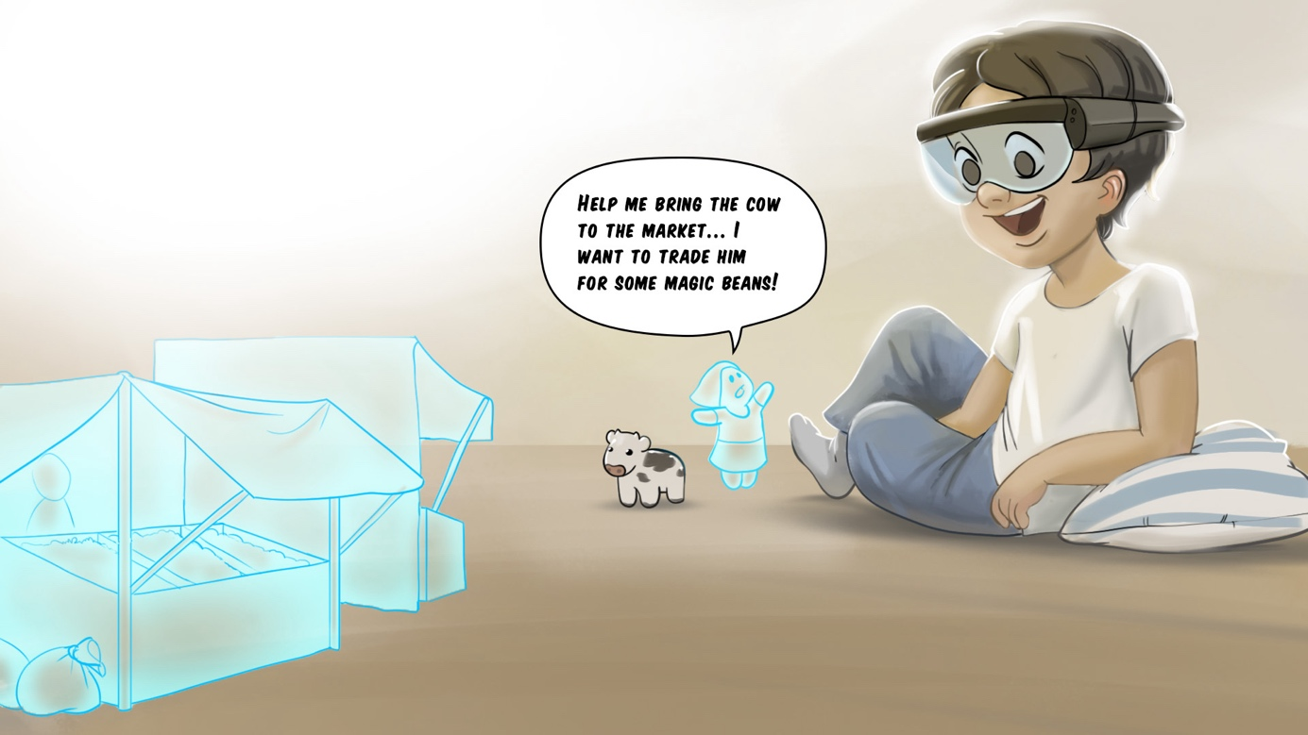

# Project Description

DisneyResearch|Studios (DRS) is collaborating with the Game Technology Center (GTC) and the Media Technology Center (MTC) at ETH Zurich to develop tools for creating intelligent characters, which inhabit augmented reality (AR) environments. The final goal of this collaboration is to have autonomous virtual characters that can navigate and interact with the real environment. One aspect of this research is the challenge of adapting artist-crafted animations to arbitrary AR interactions. While there has been a lot of research in the area of animation adaptation, not many methods are applicable to AR environments. In this thesis the student will explore existing methods and investigate how to adapt them. Depending on the interest of the student, there are opportunities to explore topics including locomotion, interaction and high-level animation control.

# Skills

* Knowledgeable in C#
* Interest or experience in animation and Unity3D

# Remarks

A written report and an oral presentation conclude the thesis. The thesis will be overseen by Prof. Robert W. Sumner, Steven Poulakos (DRS) and Manuel Braunschweiler (ETH). Please contact Steven Poulakos ([steven.poulakos@disneyresearch.com](mailto:steven.poulakos@disneyresearch.com)) for more information.